Exhaustive Analysis of Indian Agriculture Sector Using Power BI

Power Bi:

Interface of the powerBi

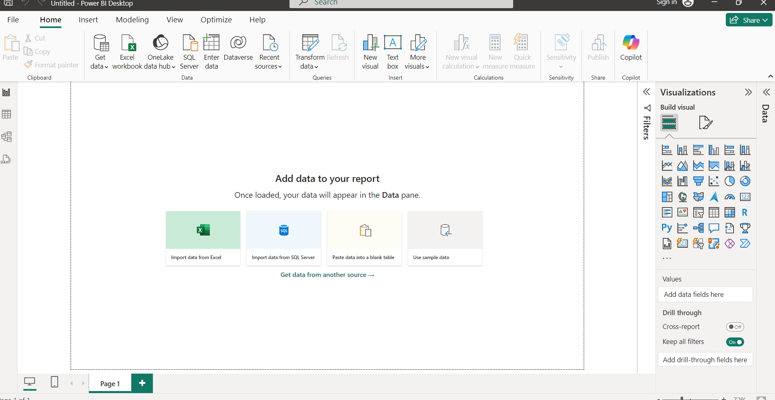

1.report view:

It is used for visualization.

2.table view:

After updated we will the data

In table view.

3.model view:

We can create the relationship

Among data .It is nothing but

Combining of data it will ideatial about the data set

To remove the null columns

At the head of that column do right click and it will show remove

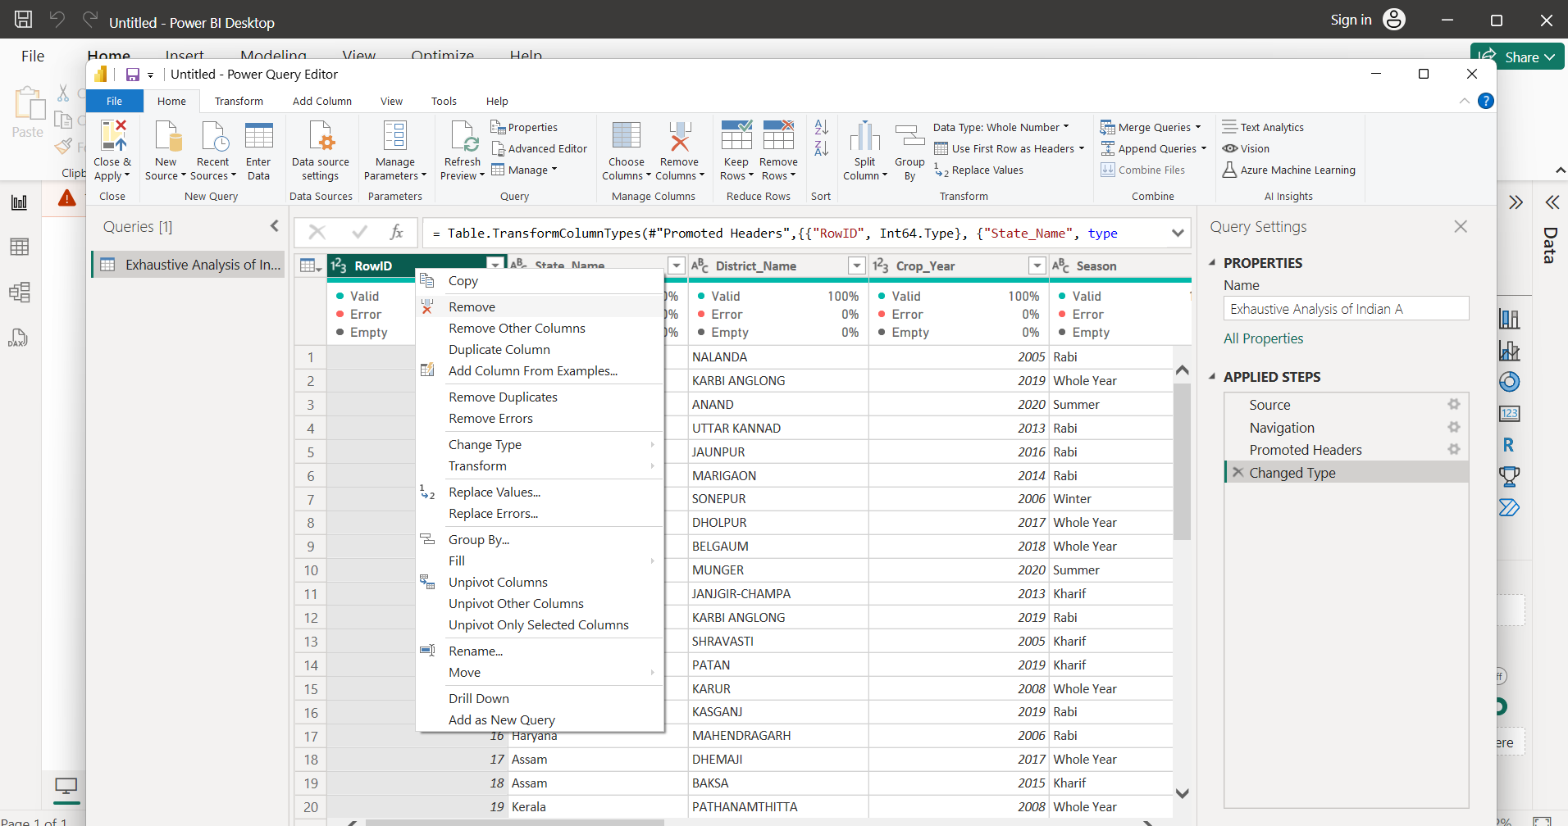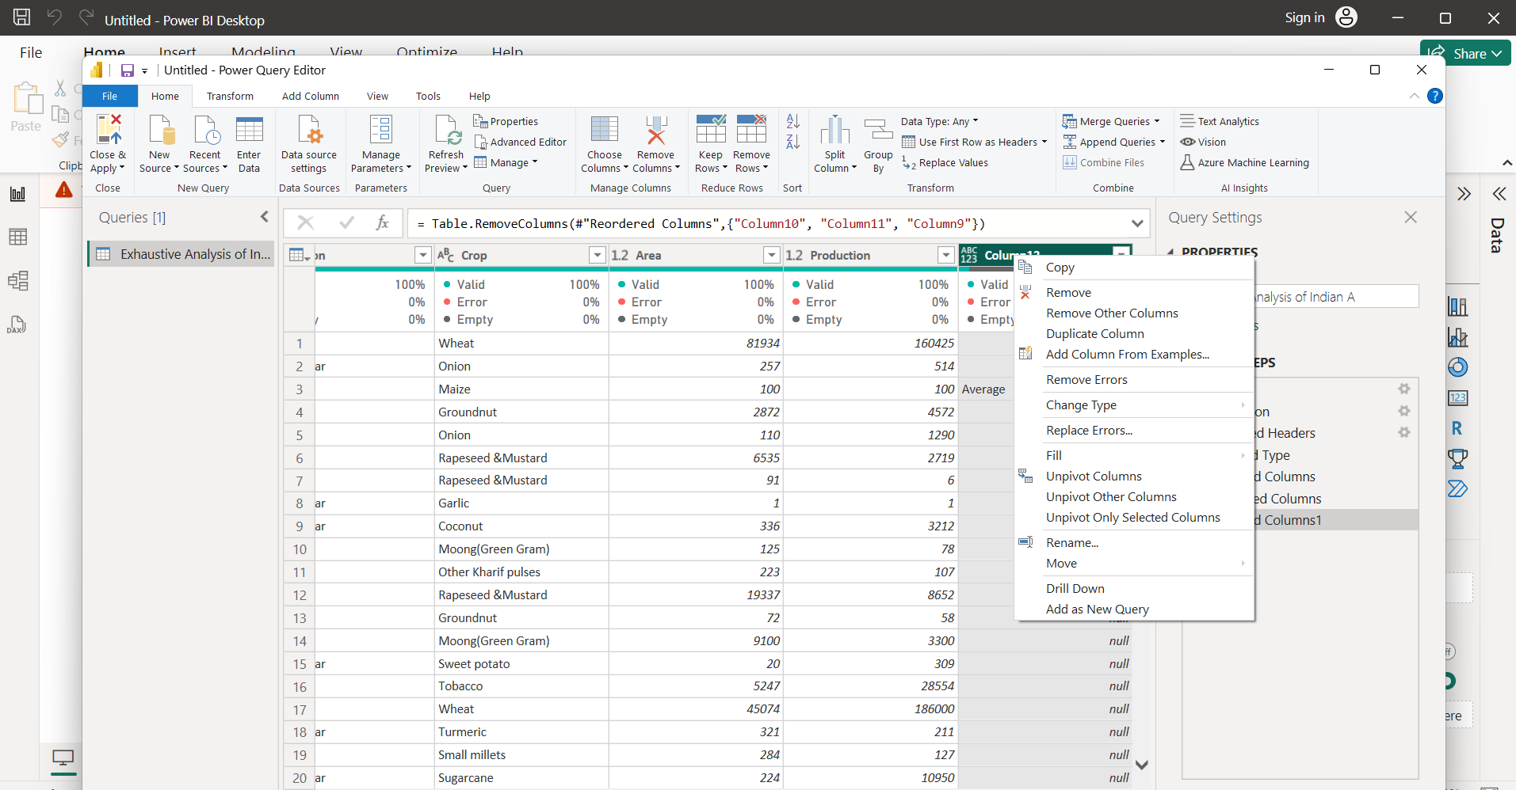

Go to view

And tick the column quality then it will provide then we will see status of the every column.

And check wheater there is any blank boxes in below.

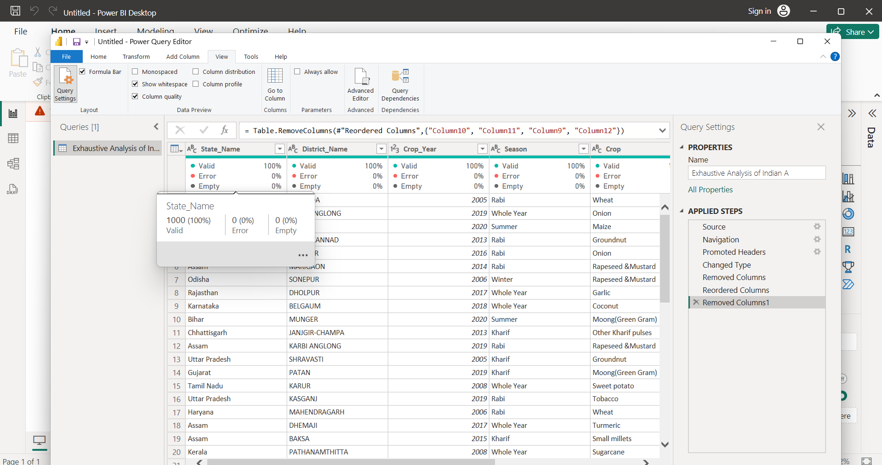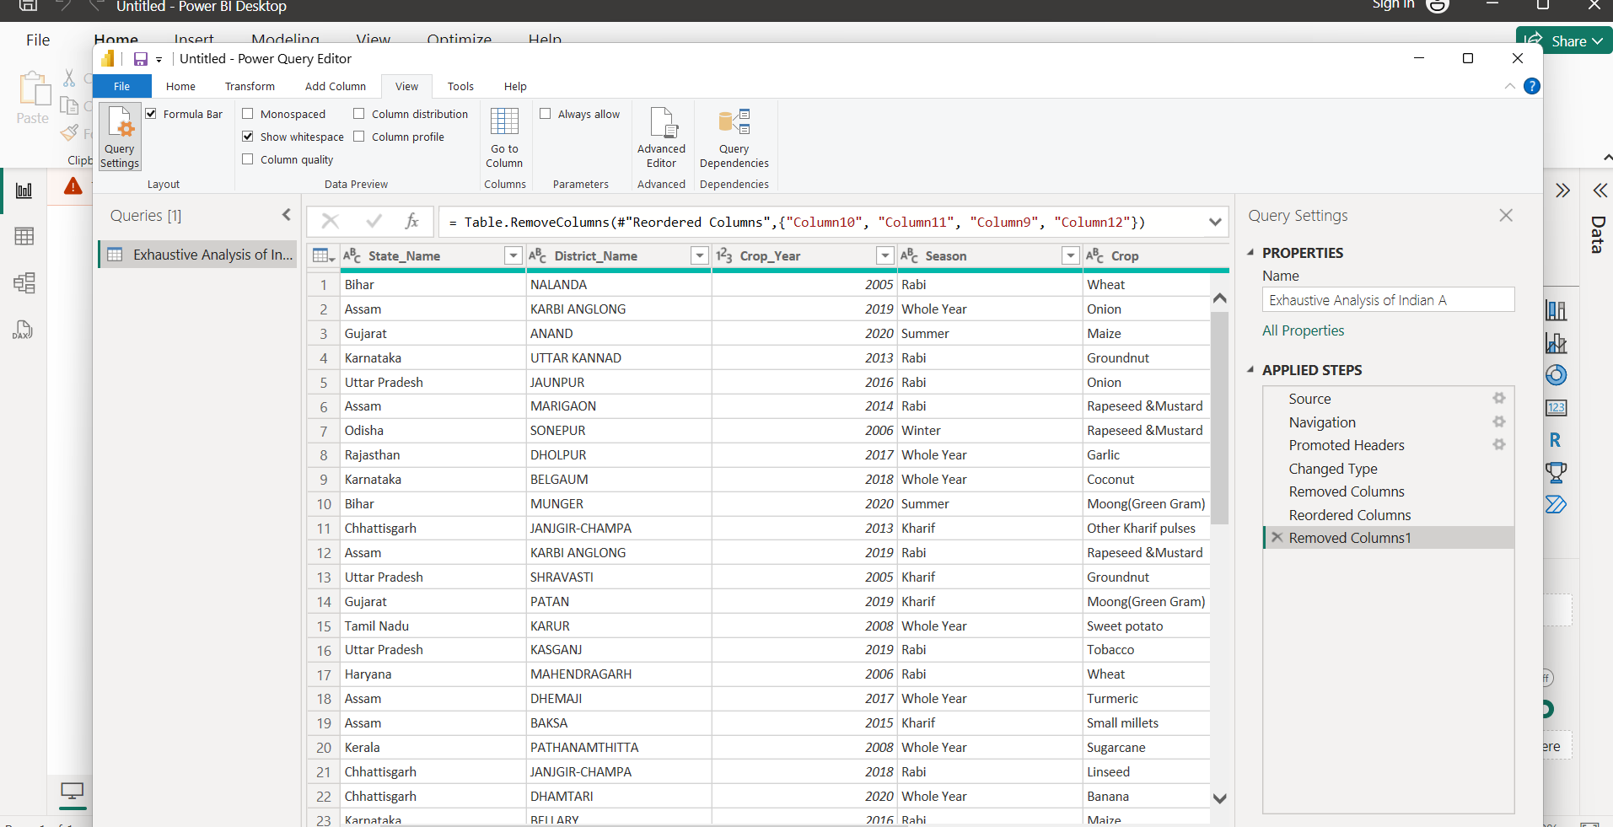

For removing the empty boxes

Go to the home and remove rows then ,

In here we will remove the duplicates

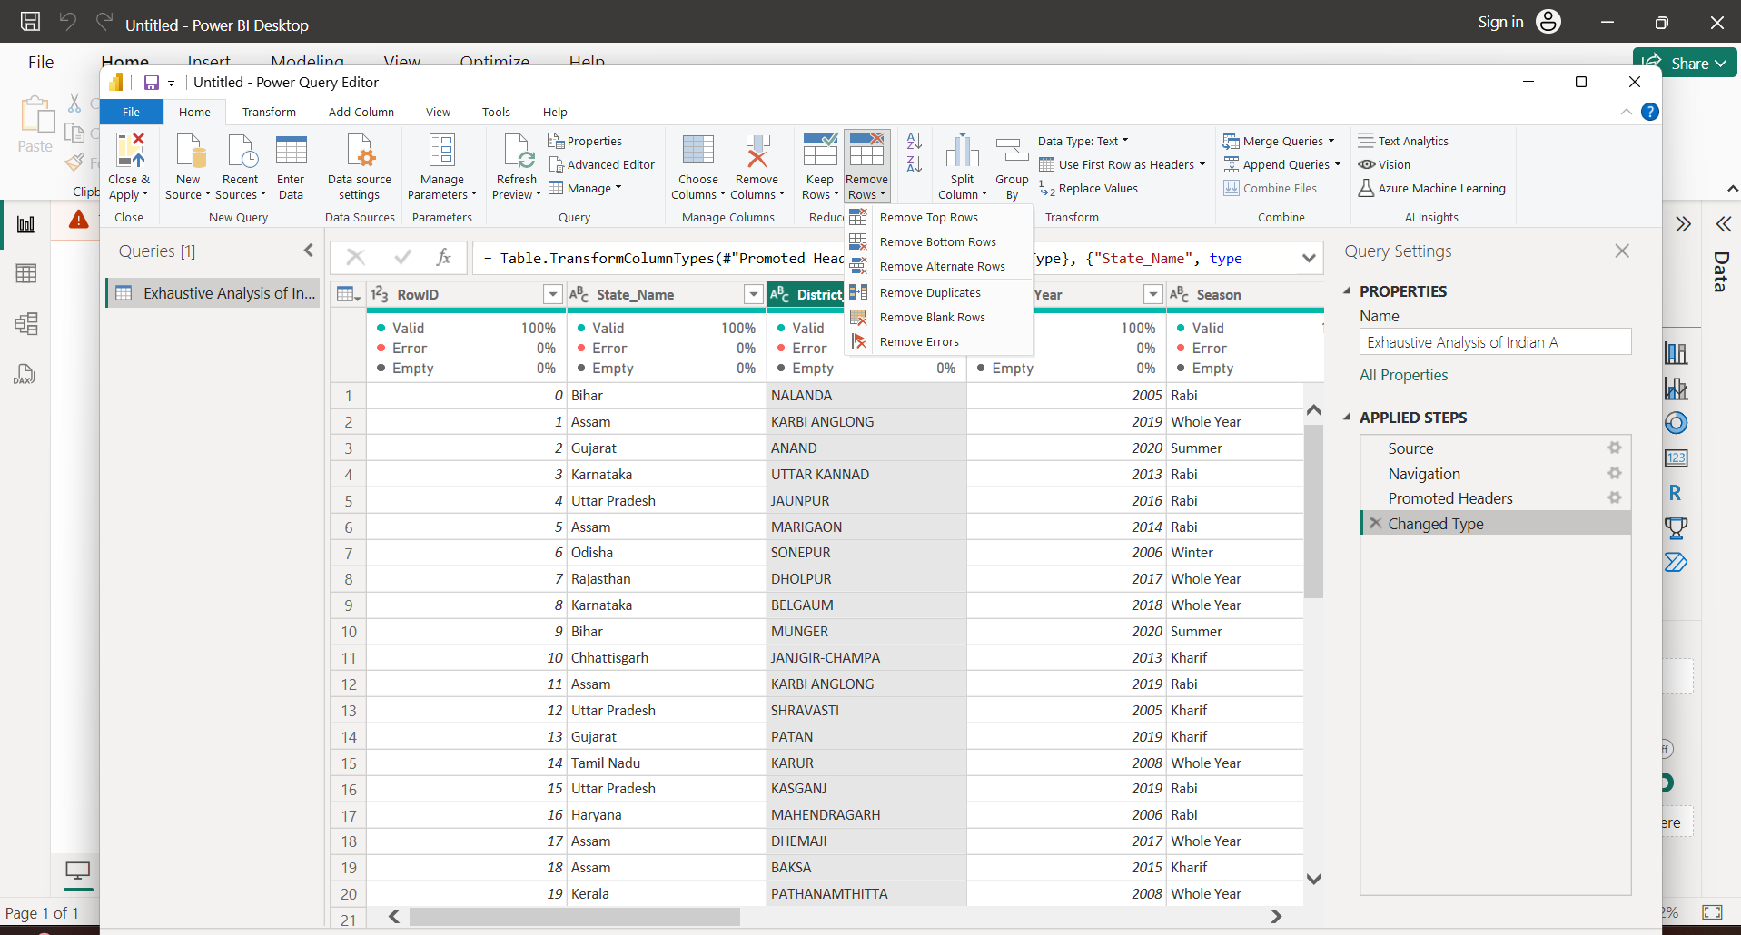 and blank rows

For the data types

Go to the column to at the place of 3 alphabets click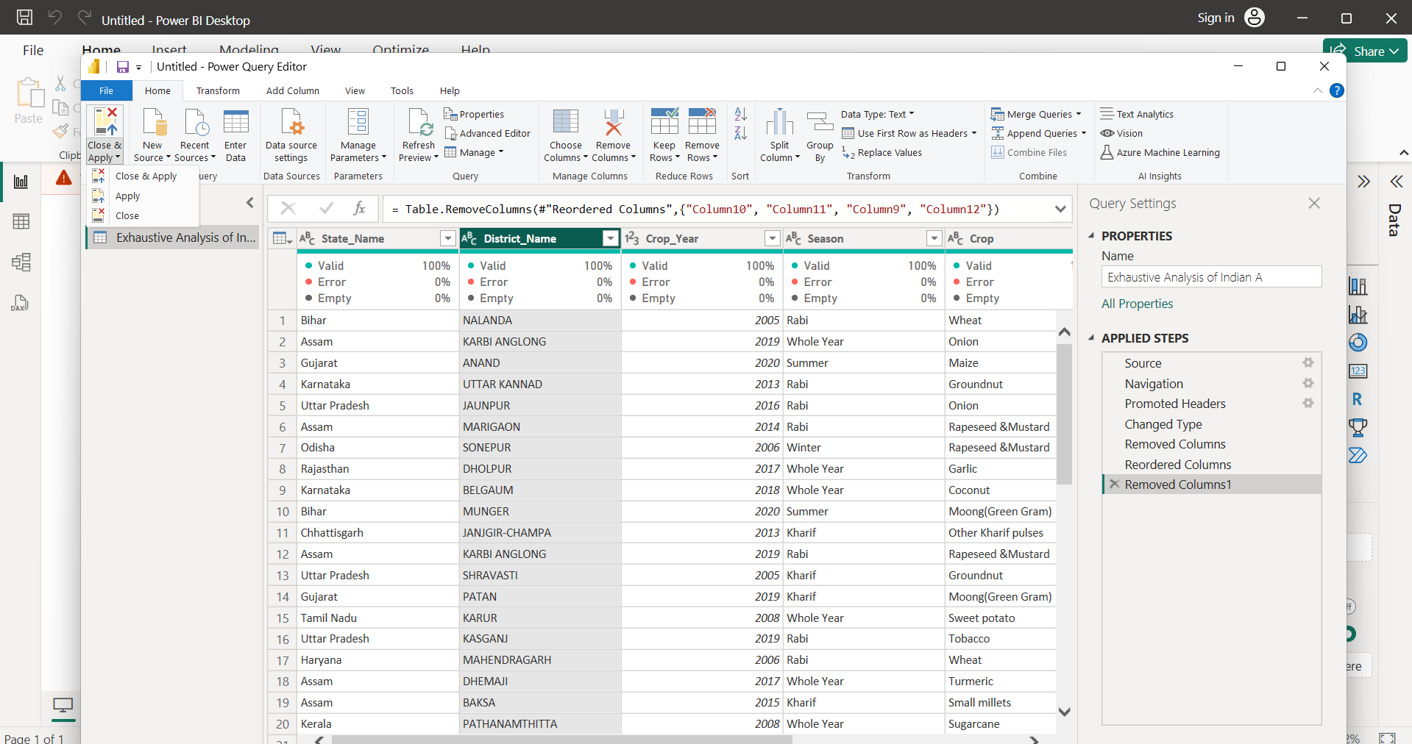

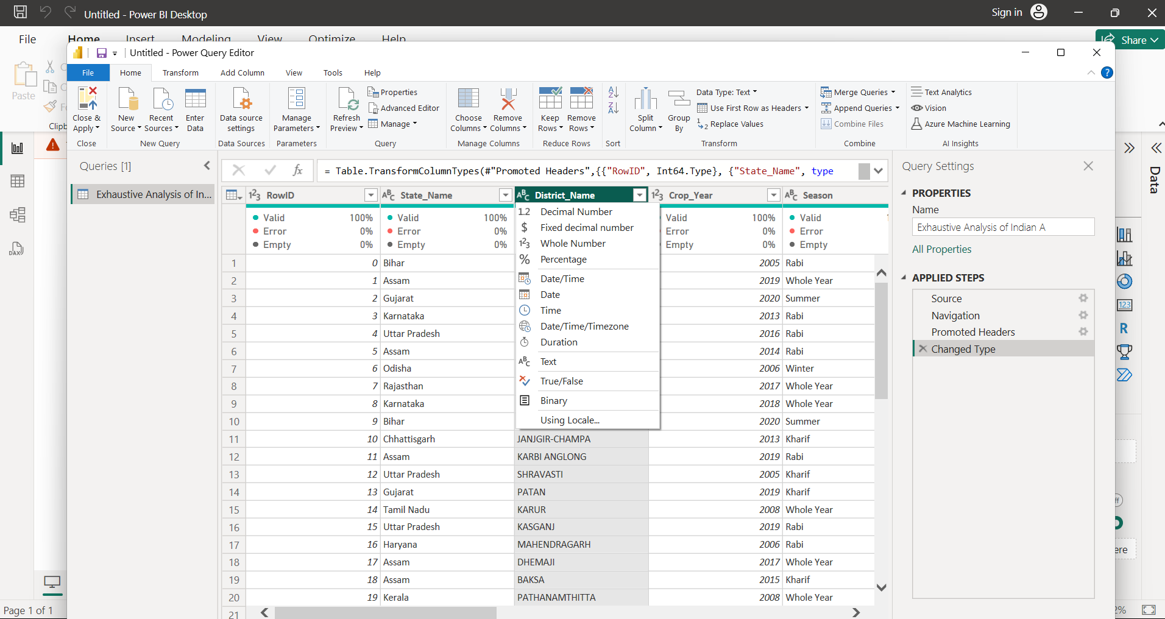

Finally the table will after transforming the data and removing the null boxes

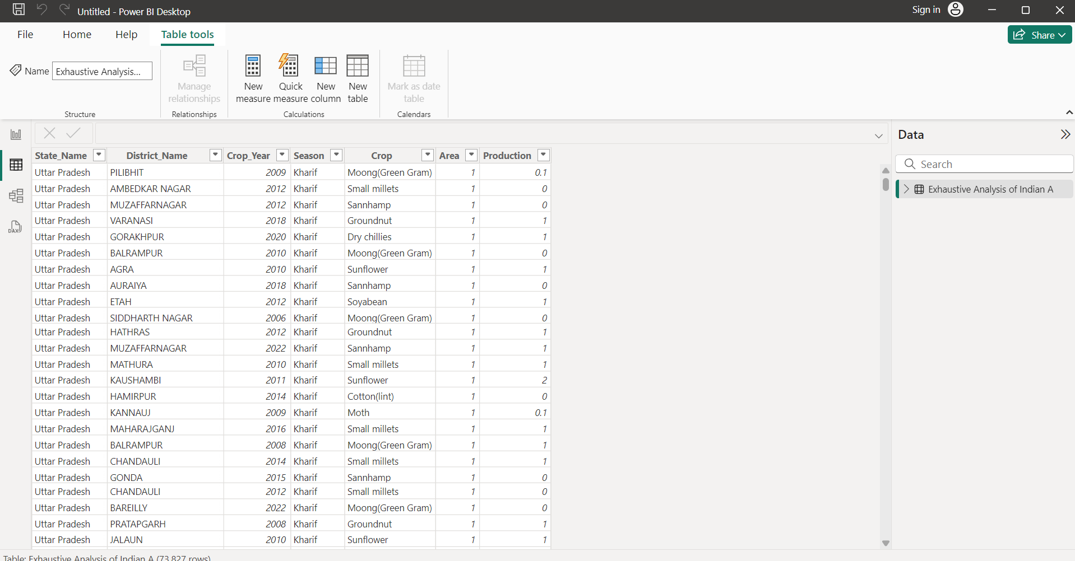

The end